ish¿u ysñlï weúßKs $ All Rights Reserved

St. Peter's College

St. Peter's College

St. Peter's College

புனித பேதுரு கல்லூரி

புனித பேதுரு கல்லூரி

புனித பேதுரு கல்லூரி

புனித பேதுரு கல்லூரி

புனித பேதுரு கல்லூரி

புனித பேதுரு கல்லூரி

புனித பேதுரு கல்லூரி

புனித பேதுரு கல்லூரி

Ydka; mS;r úÿy,

Ydka; mS;r úÿy,

Ydka; mS;r úÿy,

Ydka; mS;r úÿy,

Ydka; mS;r úÿy,

Ydka; mS;r úÿy,

Ydka; mS;r úÿy,

Ydka; mS;r úÿy,

Ydka; mS;r úÿy,

Ydka; mS;r úÿy,

St. Peter's College

St. Peter's College

St. Peter's College

St. Peter's College

St. Peter's College

St. Peter's College

St. Peter's College

St. Peter's College

St. Peter's College

St. Peter's College

புனித பேதுரு கல்லூரி

புனித பேதுரு கல்லூரி

புனித பேதுரு கல்லூரி

புனித பேதுரு கல்லூரி

புனித பேதுரு கல்லூரி

புனித பேதுரு கல்லூரி

புனித பேதுரு கல்லூரி

புனித பேதுரு கல்லூரி

Ydka; mS;r úÿy,

Ydka; mS;r úÿy,

Ydka; mS;r úÿy,

Ydka; mS;r úÿy,

Ydka; mS;r úÿy,

Ydka; mS;r úÿy,

Ydka; mS;r úÿy,

Ydka; mS;r úÿy,

Ydka; mS;r úÿy,

Ydka; mS;r úÿy,

St. Peter's College

St. Peter's College

St. Peter's College

St. Peter's College

St. Peter's College

St. Peter's College

St. Peter's College

E

I,II

**N+f.da, úoHdj**

**Geography**

**meh 02**

**Two Hours**

**08 fY%aKsh – f;jk jdr we.hsu - 2022**

**தரம் 08 - ஆண்டிறுதி மதிப்பீடு - 2022**

***Grade 08 – Third Term Examination - 2022***

Ydka; mS;r úÿy, - fld<U 04

புனித பேதுரு கல்லூரி, கொழும்பு 4

***St. Peter's College - Colombo 04***



Name: …………………………………………..…..…… Class: …….……… No: ……………

**Part – I**

* **Answer all the questions.**

**Underline the most appropriate answer.**

* **Select the correct answer from the brackets.** **(2510)**

01. The sun that emits light and heat energy is a ______________. **(Asteroid , Star , Planet)**

02. The temperature of the centre of the Sun is about _________________.

**(6000 , 15,000,000 , 15,000)**

03. When the distribution of water on the Earth is taken into consideration, Ground water is found as _________________. **(1.97% , 97.5% , 0.5%)**

04. The South Asian region possesses _____________ of the total land area of the Earth.

**(6% ,10% ,3%)**

05. _________________ marshy land is situated in the lower delta region of River Ganges.

**(Hindukush , Sulaiman , Sundraban)**

* **Mark () or () from questions 06 to 10. (2510)**

06. The Earth’s movement around the Sun is named as rotation. ( )

07. New Delhi is an ideal example for a rural landscape. ( )

08. The low level opening in highland or among the peaks of a mount is known as a gap ( )

09. The conventional sign + - - + - - + - - + is used on Provincial boundaries. ( )

10. The Caltech Astronomical Institute in U.S.A. has got information about a ninth planet that is ten times bigger than the Earth. ( )

* **Underline the correct answer from the given questions no 11 to 15. (2510)**

11. When did Galileo Galilee invent the telescope? In

i. AC 1710 ii. AC 1810 iii. AC 1610 iv. AC 1510

12. When was Pluto the planet identified as a dwarf planet?

i. 2006 ii. 2007 iii. 2008 iv. 2009

13. What is the month in which the Southern hemisphere experiences summer while the Northern hemisphere having summer in the month of June?

i. in March ii. in August iii. in September iv. in December

14. What is the South Asian country that has a crescent in a red and green background on their national flag?

i. America ii. Maldives iii. Bangladesh iv. Pakistan

15. Out of 14 highest peaks in the world how many peaks are found in the Himalayas range?

i. 7 peaks ii. 9 peaks iii. 8 peaks iv. 10 peaks

* **Write the correct answer on the dotted line for questions from 16 to 20.** **(2510)**

16. The main source of income in Maldives is fishing industry and _____________.

17. The natural features seen on the land are known as physical features and manmade features are known as _____________.

18. The highest gravitational force is found on the planet _____________ among the planets.

19. Haumea is a _____________ planet.

20. The Earth has been divided into 24 regions or time zones on the basis of _____________ for the use of internationally accepted standard time.

**Part – II**

* **Answer five questions altogether.**
* **The first question is compulsory.**

**01.** A). **Answer the questions with the help of the maps given in the paper.**

i. Name the two points A and B on the map. **(02)**

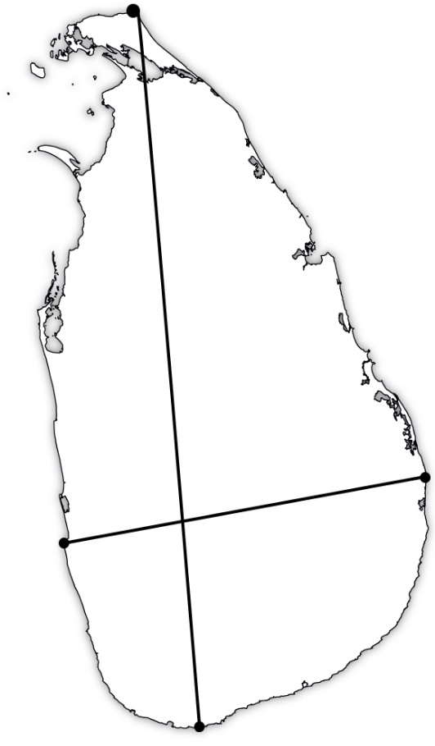

**A**

**B**

**C**

**D**

A - ______________________________

B - ______________________________

ii. Name the two points C and D on the map. **(02)**

C - ______________________________

D - ______________________________

iii. Write the length of the line from A to B on the map **(02)**

___________________________________

iv. Write the width of the line from C to D on the map. **(02)**

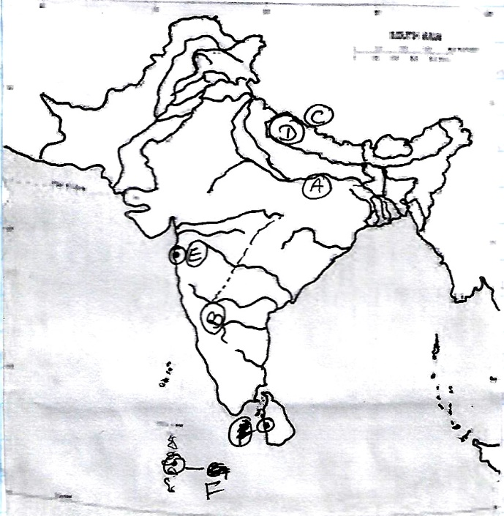

B). i. Name the river labeled as (A) **(02)**

A - ______________________________

ii. Name the letter B. **(02)**

B - ______________________________

iii. Name the mountains as, **(02)**

C - ______________________________

D - ______________________________

iv. Name the towns E and F **(02)**

E - ______________________________

F - ______________________________

02. i. What is the meant by the solar system? **(02)**

ii. Name 03 celestial bodies that belong to the solar system. **(03)**

iii. Name the diagrams given. **(06)**

**(Total – 11)**

**A B C**

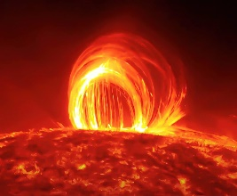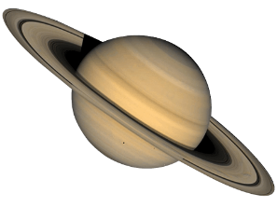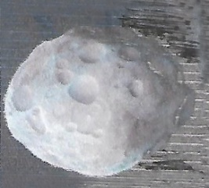

**_______________ __________________ ______________**

03. i. Some information on the Earth are given below. Fill in the blanks with relevant calculations. **(02)**

A - Distance from the Sun -

B - time of revolution -

ii. Give 03 reasons, that Earth has become favourable for the man. **(03)**

iii. Write 03 seasons occur on the Earth and, give a short explanation on one. **(06)**

**(Total – 11)**

04. i. Name two boundaries of South Asian region. **(02)**

ii. Name 03 countries in the South Asian region with their capitals. **(03)**

iii. What are the countries that the given National Flags belong to, **(06)**

**(Total – 11)**

**A B C**

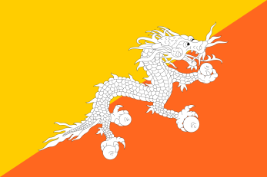

**_______________ __________________ ______________**

05. i. Name 02 human activities seen in the coastal landscape. **(02)**

ii. Name 03 Tourist attraction places in the coastal landscape. **(03)**

iii. Give short notes on given landscapes. **(06)**

A). Rural landscape.

B). Valley landscape.

**(Total – 11)**

06. i. What is meant by a 1 : 50,000 map? **(02)**

ii. Name some physical features of given relief. (contour line maps) **(03)**

**A B C**

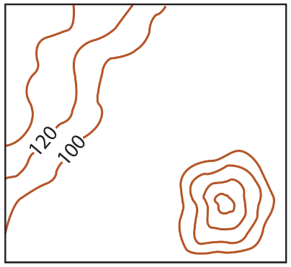

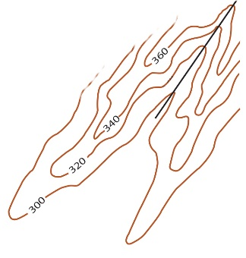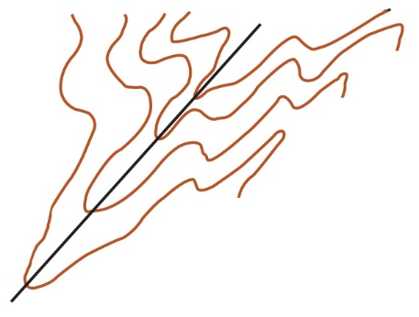

**_________________ _________________ _________________**

iii. Draw the relevant conventional signs for the boundries given. **(06)**

A - A. G. A. divisions -

B - Urban council limits -

C - District limits - **(Total – 11)**

07. i. Name 02 tribes found in the Himalayan Mountains. **(02)**

ii. Give 03 physical features of people live in mountain landscape. **(03)**

iii. Name the parts given in the diagram. **(03)**

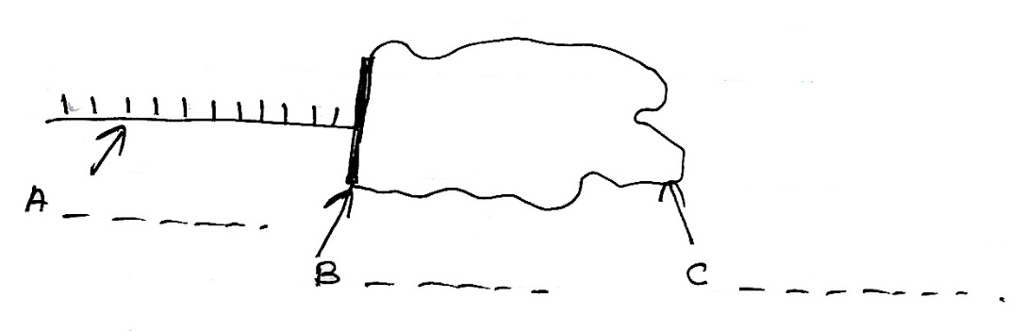

A - ______________________ B - ______________________

C - ______________________

iv. Draw the relevant conventional signs. **(03)**

A - Post office

B - School

C - Courts **(Total – 11)**